Figure 1.
Overall Sequence Diagram. It is a basic flow of what a user generally can do on the website.
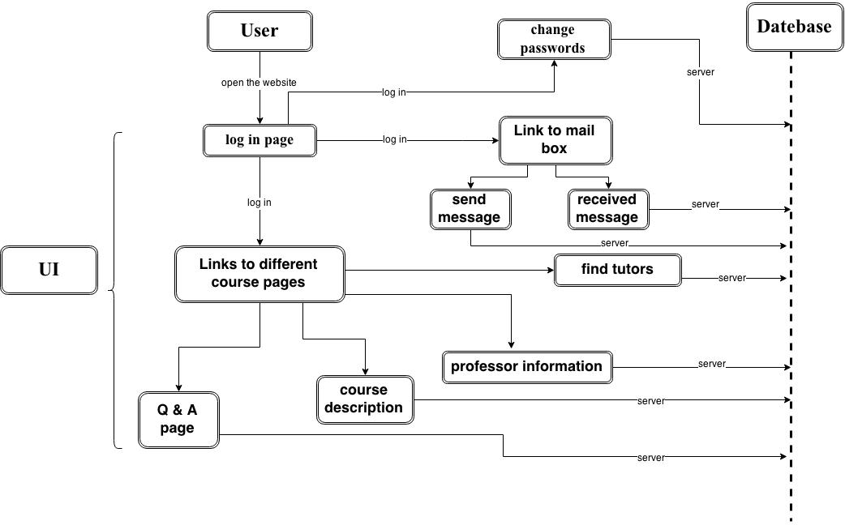
Figure 2.
Password Changing Diagram. In some cases that a user need to change password, our website allows him to change it.
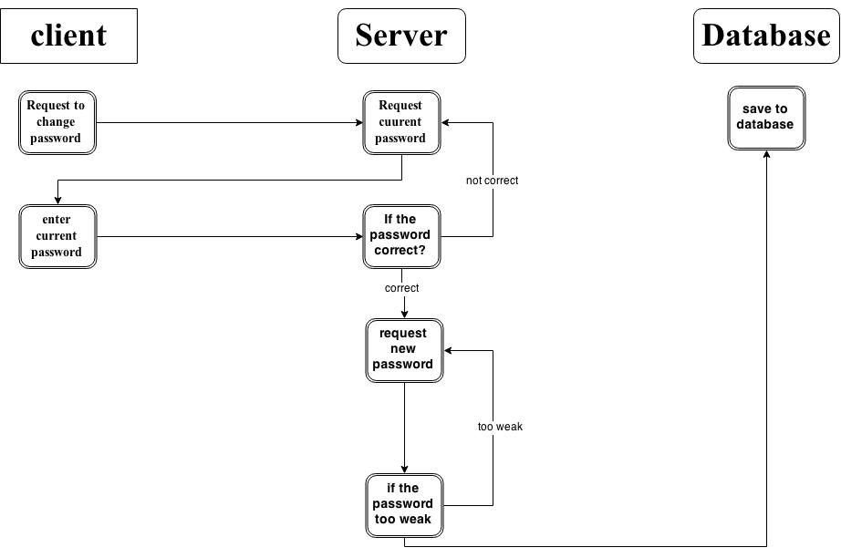

Figure 3.
Message sending/receiving Diagram. Users can send messages to someone else on our website.
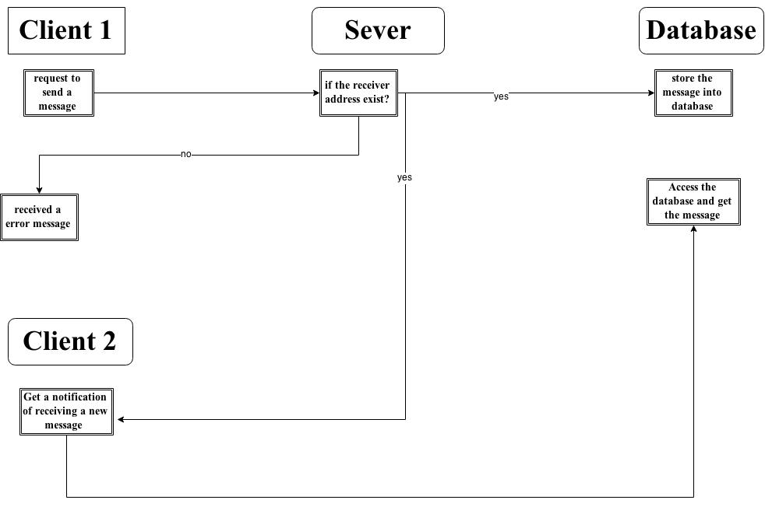

Figure 4
Q & A Diagram. Users could post questions online and professors and other classmates could answer their questions or discuss about the topic.
